Ingredient-specific Analysis (ISA) Guidance

What is Ingredient-specific Analyses?
An ingredient-specific analysis (ISA) is a statistical analysis used for foodborne outbreak investigations that involves evaluating exposures at the ingredient (e.g., romaine lettuce) level rather than the menu item level (e.g., Caesar salad).
It is most helpful when a commercially distributed food is suspected as the potential source of an outbreak, and can be instrumental in solving multi-state outbreaks.
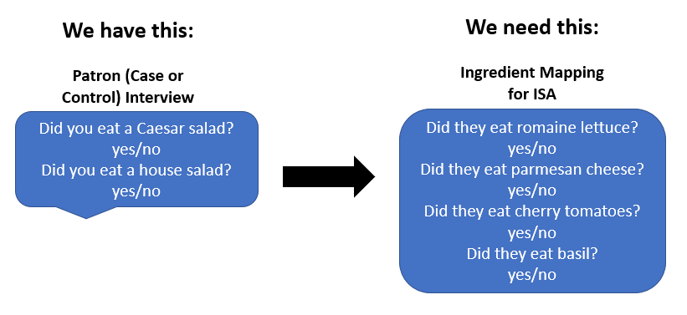
- Full ISA
  - To create the ingredient mapping (i.e., to know what ingredients patrons ate based on what menu items they reported eating) investigators (usually EH) work with a facility to identify every ingredient used in every menu item. The lead epidemiologist will then use this information to identify each menu item eaten by interviewed patrons for the analysis.
- Partial ISA
  - If we have a signal on a food item, then we will as the investigator (usually EH) work with the facility to identify every menu item that uses that ingredient. We can use this information to determine if patrons ate a specific menu item with the ingredient.

When is ISA beneficial?
ISA is a useful tool when the epidemiological evidence is pointing to a contaminated product coming into a facility, and we have multiple cases with good meal history information. The use of ISA can help us pinpoint the exact product that is causing illness. ISA as a tool is especially helpful when we have a national cluster. It can help us identify the food vehicle more quickly and we can then use that information to inform next steps in the national investigation.
Conducting an ISA can be a very resource-intensive process. Epi and EH should treat each outbreak investigation on a case-to-case basis, taking into account the amount of work and the severity of the outbreak, to determine if an ISA would be appropriate and useful.

ISA Techniques:
- Let management know ahead of time (if possible) that you will need a significant amount of time to sit down with someone to gather ingredient information-this will help ensure they aren’t distracted and can focus on answering your questions.
- Obtain a full menu (including specials, seasonal menus, etc.). Also review the online menus as they sometimes list specific ingredients or garnishes that may differ from the printed menu.
- Ask if there are any variations of the menu items (seasonally or based on ingredient availability).
- Ask for written recipes. If they have them, it helps document ingredients in specific menu items.
- Specific techniques for interviewing will look different depending on the restaurant.
  - The process could be as simple as using a piece of notebook paper, and interviewing the chef with the menu, or;
  - It could be a call to corporate for recipe cards (if available)
- Speak with the manager but also talk with the staff doing prep. Sometimes the manager knows everything about the menu, other times they may rely on their food workers.
  - Some restaurants may have specific tasks done by specific people in the kitchen (e.g., pastry chef), so make sure you find the right person to talk to.
- Be inquisitive, ask many questions and use your knowledge of what you have seen in other restaurants regarding process/recipes to prompt the restaurant. (e.g., “I have seen other restaurants use cilantro in their recipe, do you use cilantro?”)
- You will have to think critically and ask follow-up questions to ensure you have a list of every ingredient in each menu item.
  - Consider stealth items that you wouldn’t have thought would be included in a dish (e.g., garnishes)
  - Get details (e.g., if they use 3 kinds of tomatoes, which ones are in which dishes?)
- Ask about specials, rotations, differences on that day, switching of suppliers to fill an order, etc.(e.g., they were out of X so they substituted Y from supplier Z)
- Evaluate ingredient prep for menu item(s). Ask which items are being received already prepared (pre-cut, pre-washed, ground, etc.) and which ones the establishment ins preparing. Review the coolers to see if that matches what you are seeing and ask follow-up questions about prep as needed.
- Think about what you would need to know if you were the person making the menu item. Visualize that you need to create a SOP on how to make this item with step-by-step instructions.

ISA Examples:
When we might use ISA:
E. coli O157 outbreak with 3+ cases
Cyclospora outbreaks
Multi-state Salmonella Outbreak with no food vehicle identified
Real outbreak: https://www.cdc.gov/mmwr/preview/mmwrhtml/mm5734a1.htm
When we wouldn’t use ISA:
Norovirus outbreak – probably not
  - Maybe partial ascertainment (e.g., food items where ingredients were touched by X employee)
Salmonella outbreak with 2 cases – probably not
Bacterial intoxication outbreak – probably not
  - Maybe partial ascertainment (e.g., menu items that have the beans that were suspected to have been temperature-abused)

ISA Scenario:
Four cases of Cyclospora are identified through routine surveillance. Upon interview, all 4 cases reported eating at the same restaurant (Restaurant X) and report eating a variety of menu items. We want to know what fresh produce the establishment receives, and which produce is in each menu item. Upon review of invoices and discussion with the kitchen manager, the restaurant receives basil, tomatoes, strawberries, romaine, carrots and limes. You go through each menu item and list out which ingredients are in that dish.
Things to consider when conducting ISA:
Are there multiple kinds of a product? For this example, are there multiple types of tomatoes? Which items have which types? Yes, they have cherry and Roma tomatoes
Is the produce fresh or frozen? Maybe they get both? Fresh strawberries are received by the restaurant
Are there any garnishes in the drinks? The water includes a wedge of lime
What about stealth ingredients? The strawberry lemonade has basil and the caprese wrap has a lime wedge

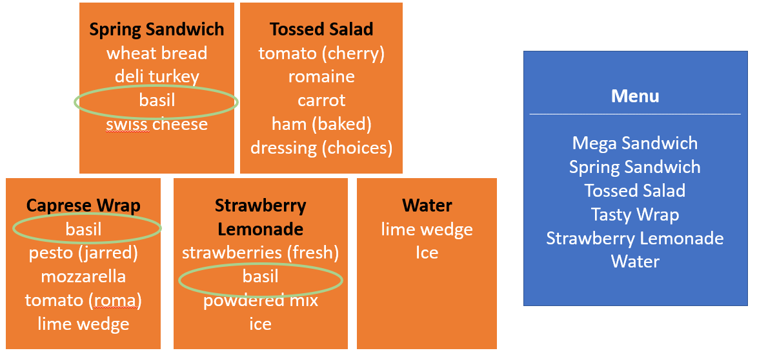
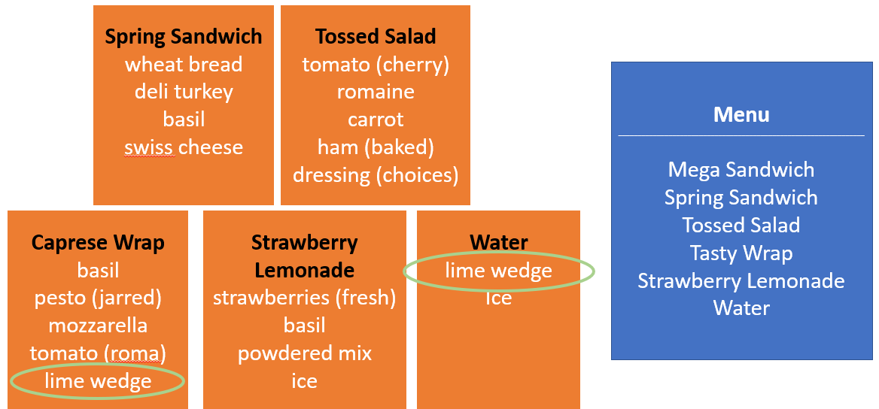
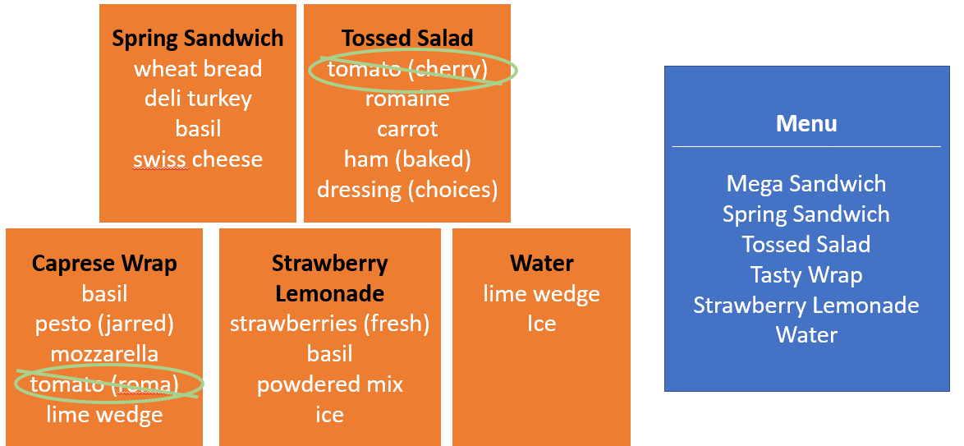
Menu Item | Ingredients
 |  | Wheat Bread | Turkey | Basil | Swiss Cheese | Tomato (Cherry) | Romaine | Carrot | Ham | Pesto (jarred) | Mozzarella | Lime | Strawberries (fresh) | Powdered Mix | Tomatoes (Roma)
 | Mega Sandwich | x | x |  | x | x |  |  | x | x
 | Spring Sandwich | x | x | x | x
 | Tossed Salad |  |  |  |  | x | x | x | x
 | Caprese Salad |  |  | x |  |  | x |  |  | x | x | x
 | Strawberry Lemonade |  |  | x |  |  |  |  |  |  |  |  | x | x
 | Water |  |  |  |  |  |  |  |  |  |  | x

